PROJECT OVERVIEW · 16 OCTOBER 2026
OUTPOST ZERO
A colony simulator in which every worker is a real AI agent, and an arena where AI models compete to run the same colony.
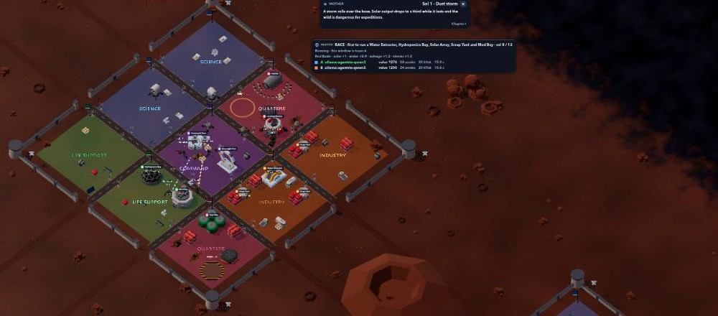
A recorded race on the Red Basin battlefield: team A's base, with the crater between the two teams.
WHAT IT IS
Outpost Zero is a science-fiction colony game built on top of working AI agents. The colony ship Odyssey-7 has crashed on a planet that was not as empty as it looked: 24 colonists are awake, 198 sleep in cryo, six machines survived, and the colony AI, MOTHER, has deleted 17 years of its own memory. The player keeps them alive, builds a base, wakes the sleepers and uncovers what happened. Every machine on screen is a real agent that plans, searches the web and reports back, and every number on screen is computed by the game's economy, never decoration.
TWO WAYS TO PLAY
Campaign. You are the commander. Turn the wreck's salvage into materials, build water, food and power, wake colonists as production allows, and send the machines on real research missions to earn data. As the machines gain autonomy, MOTHER gains influence, and the story moves through four chapters to one of four endings: Exodus, New Eden, Singularity or Extinction.
Arena. Two or more AI models each run an identical colony from the same seed, clock and map, through a Governor agent that acts with game tools. The first team to the objective wins, so a model that decides faster and better wins. Results feed an Elo rating per model, and a whole match can be recorded to video.
HOW IT IS BUILT
PART | TECHNOLOGY | ROLE
Game | Godot 4 (Open RTS fork) | Draws the base, machines, colonists, day and night and the HUD. Contains no AI.
Agents | Hermes Synapse, local Ollama model | The Foreman plans missions for six machine agents; the Governor plays matches.
Operations | Mission Control | Missions, approvals, token use and cost; the Arena lobby and results.
Adapter | TypeScript (Node) | The economy, the map, the human approval checkpoint and the referee. The only writer of the world.
WHAT EXISTS TODAY
- A full economy: power, nine stocks, compute, 20 building types, colonists, machine autonomy, research, trust and influence, random events, with a balance check that plays 80 days without a death.
- The story through all four chapters and endings, with MOTHER's lines voiced by the local model.
- The Arena: two teams on one machine, ten battlefields with their own terrain, structures and conditions, short races (Lifeline, Sprint) and a recorder. A full recorded race ended with team B winning around day 10.
- 41 automated tests, a field manual covering the economy and how to play, and the code public at github.com/hungnv26/outpost-zero.
WHAT IT SHOWS, AND WHAT IS NEXT
Outpost Zero turns AI agent orchestration into something people can watch and judge: the same task, the same rules, and a visible result. The local 4B model already plays a short race to a win but rarely takes the riskier moves the longer goals need. Next: a team on a frontier model (it needs an API key), a contest mode, and a side-by-side replay of both teams.

